Chi-Square test

**Association between Device Type and Customer Satisfaction**

**Background:**

Mizzare Corporation has collected data on customer satisfaction levels for two types of smart home devices: Smart Thermostats and Smart Lights. They want to determine if there's a significant association between the type of device purchased and the customer's satisfaction level.

**Data Provided:**

The data is summarized in a contingency table showing the counts of customers in each satisfaction level for both types of devices:

| **Satisfaction** | **Smart Thermostat** | **Smart Light** | **Total** |
| --- | --- | --- | --- |
| Very Satisfied | 50 | 70 | 120 |
| Satisfied | 80 | 100 | 180 |
| Neutral | 60 | 90 | 150 |
| Unsatisfied | 30 | 50 | 80 |
| Very Unsatisfied | 20 | 50 | 70 |
| **Total** | 240 | 360 | 600 |

**Objective:**

To use the Chi-Square test for independence to determine if there's a significant association between the type of smart home device purchased (Smart Thermostats vs. Smart Lights) and the customer satisfaction level.

**Assignment Tasks:**

**1. State the Hypotheses:**

Based on the below Chi-Square results it is clear that there is no relation between the device purchased and customer satisfaction. Hence, reject null hypothesis (H0) and accept Alternative Hypothesis as there is no relation between customer satisfaction and device purchased.

1). Chi-Square(Very Satisfied-Smart Thermostat)= (240*120)/600 = 48

2). Chi-Square(Very Satisfied-SmartLight)= (360*120)/600=72

3). Chi-Square(Satisfied-Smart Thermostat)= (240*180)/600 = 72

4). Chi-Square(Satisfied-SmartLight)= (360*180)/600=108

5). Chi-Square(Nuetral-Smart Thermostat)= (240*150)/600 = 60

6). Chi-Square(Nuetral-SmartLight)= (360*150)/600=90

7). Chi-Square(Unsatisfied-Smart Thermostat)= (240*80)/600 = 32

8). Chi-Square(Unsatisfied-SmartLight)= (360*80)/600=48

7). Chi-Square(Very Unsatisfied-Smart Thermostat)= (240*70)/600 = 28

8). Chi-Square(Very Unsatisfied-SmartLight)= (360*70)/600=42

**2. Compute the Chi-Square Statistic:**

X1_static_VerySatisfied= (50-48)*(50-48)/48 + (70-72)*(70-72)/72

X1_static_ VerySatisfied = 4/48+4/72= 0.0833+0.0555= 0.139

X2_static_Satisfied= 0.8889+ 0.5926= 1.4815

X3_static_Neutral= 0+0=0

X4_static_Unsatisfied= 0.125+0.0833= 0.2083

X5_static_VUnsatisfied= 2.2857+1.5238= 3.8095

**3. Determine the Critical Value:**

Using the significance level (alpha) of 0.05 and the degrees of freedom (which is the number of categories minus 1)

Alpha= 0.05

DF= No of Categories-1 = 5-1=4

DF= 4

From Chi-Square table, Critical Value for 4 DF and 0.05 is 9.488

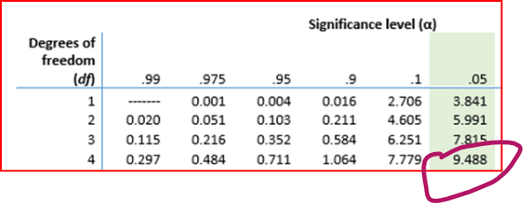

**4. Make a Decision:**

Compare the Chi-Square statistic with the critical value to decide whether to reject the null hypothesis.

**Submission Guidelines:**

* Provide a detailed report of your analysis, including each step outlined in the assignment tasks in a python file.
* Include all calculations, the Chi-Square statistic, the critical value, and your conclusion.